PERSONAL INFORMATION | Achille Iolascon
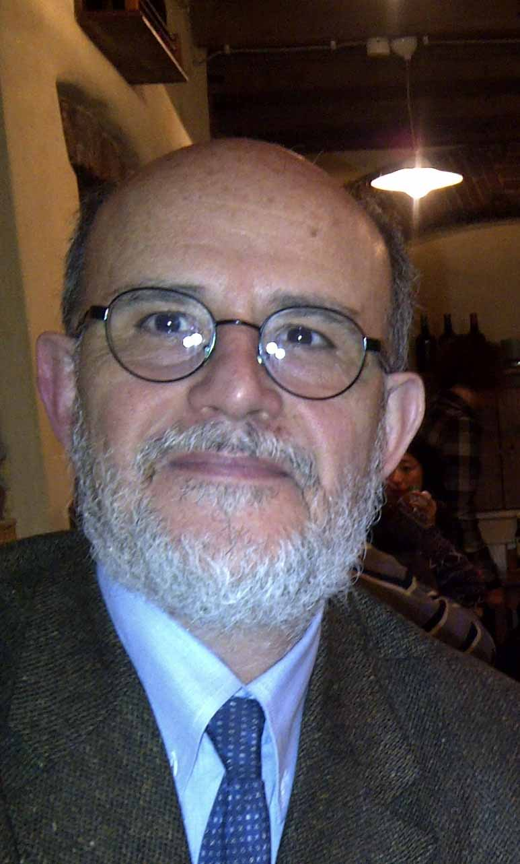 | University of Naples "Federico II"  Department Molecular Medicine and Medical Biotechnologies  CEINGE, biotecnologie avanzate,  Via G. Salvatore, 486, 80145, Naples, Italy
 | +39 0813737897 +39 3334080672
 | Achille.iolascon@unina.it
 | https://www.docenti.unina.it/achille.iolascon
 | Sex M | Date of birth 29/04/1954 | Nationality Italian

Enterprise | University | EPR
☐ Management Level | ☒ Full professor | ☐ Research Director and 1st level Technologist / First Researcher and 2nd level Technologist / Principal Investigator
☐ Mid-Management Level | ☐ Associate Professor | ☐ Level III Researcher and Technologist
☐ Employee / worker level | ☐ Researcher and Technologist of IV, V, VI and VII level / Technical collaborator | ☐ Researcher and Technologist of IV, V, VI and VII level / Technical collaborator

WORK EXPERIENCE

(from 2005 - to present)  (from 2005- to present)  (from 2004 - to present)  (from 2004 - to present)  (from 2000 - to 2003)  (from 1994 - to 1999) | Director of the residency school of Medical Genetics
Department of Molecular Medicine and Medical Biotechnologies/University of Naples Federico II/Italy
Full Professor of Medical Genetics
Department of Molecular Medicine and Medical Biotechnologies/University of Naples Federico II/Italy
Principal Investigator and Head of Laboratory Medical Genetics Unit
CEINGE Biotecnologie Avanzate/Naples/Italy
Director of Clinical Medical Genetics Unit
UOC Genetica Medica, AOU Federico II/Naples/Italy
Professor of Pediatrics and Director of Dept of Pediatrics
Department of Pediatrics/University of Foggia/Italy
Associate Professor of Pediatrics
Department of Pediatrics/University of Naples/Italy
- Study of clinical and molecular genetics of rare hereditary disorders/hereditary anemias/ neuroblastoma.
- Skills: Clinical genetics, Molecular genetics, cancer genetics, NGS analysis; genome editing; clinical trials, pre-clinical drug studies; drug discovery; biomarkers discovery; RNA drug development.
- Teaching activities: Full professor – Medical Genetics/School of Medicine/Residency School of Medical Genetics University Federico II, Napoli/Italy.
- Group leader: 3 RTDB, 2 Medical Geneticists, 1 PhD student, 14 post graduate students in Medical Genetics (physicians and biologists), 2 technicians.
EDUCATION AND TRAINING

(1986)  (from 1982- to 1985)  (from 1978- to 1981)  (from 1972- to 1978) | PhD in Pediatrics
 | University of Naples, Italy
Post-graduate Residency school in Oncology
University of Naples, Italy
Post-graduate Residency school in Pediatrics
University of Naples, Italy
Master degree in Medicine
University of Naples, Italy

WORK ACTIVITIES

Editorial activity | - Associate Editor “American Journal of Hematology”.  - Associate Editor “Scientific Report”.  - Associate Editor “Frontiries in Phisiology”.  - Associate Editor “Frontiries in Genetics”.  - Associate Editor “Genes”.
Invited presentations | - EHA-SWG Scientific Meeting on Red Cell and Iron Metabolism: from basic science to clinical case application. Madrid, Spain; “Clinical cases of CDA”. 2019.  - ESH - International Conference on Erythropoiesis Control and Ineffective Erythropoiesis. Hereditary congenital dyserythropoiesis anemias. Budapest 2019.  - Conference "Egyptian Society of Pediatric Hematology-Oncology ESPHO 2018 Egypt. “Hereditary red blood cell defects” 2018.  - Red Cell Conference, “Hereditary Stomatocytosis”, Yale School of Medicine, CT, USA, 2012.
Grants | 2022-2024. Principal Investigator of the project "Understanding dyserythropoiesis to identify new therapeutic mechanisms in hereditary anemias". PRIN.  2018-2022. Principal Investigator of the project "Understanding the role of non-coding variants in primary and relapsed neuroblastoma". AIRC.  2017 - 2020: Co-Principal Investigator of the project "Towards the improvement of diagnosis and treatment in Congenital Dyserythropoyetic Anaemias (CoDysAn project)" - research project for “ayuda a la investigación en ciencias de la vida” Fundacion ramón areces.
Other appointments | 2020-2022 – President of the Italian Society of Human Genetics (SIGU)  2014-2021 - Chairman of the scientific working group of the European Hematology Association on Red Cells and Iron  2016- present - Chairman of the EuroBloodNet group on Benign hematology.
ADDITIONAL INFORMATION

Publications  Collaborations | H-Index: 59, N. publications: 398, Total citations: 3495, N. publications 10 years: 160  Relevant publications  - Capasso M, .., Iolascon A. Transcription Factors Involved in Tumorigenesis Are Over-Represented in Mutated Active DNA-Binding Sites in Neuroblastoma. Cancer Res. 2020 Feb 1;80(3):382-393.  - Andolfo I, ... Russo R, Iolascon A. Gain-of-function mutations in PIEZO1 directly impair hepatic iron metabolism via the inhibition of the BMP/SMADs pathway. Am J Hematol. 2020;95(2):188-197.  - Andolfo I, Russo R, ... Iolascon A. Genotype-phenotype correlation and risk stratification in a cohort of 123 hereditary stomatocytosis patients. Am J Hematol. 2018;93(12):1509-1517.  - Russo R, Andolfo I, .., Iolascon A. GATA1 erythroid-specific regulation of SEC23B expression and its implication in the pathogenesis of congenital dyserythropoietic anemia type II. Haematologica. 2017 Sep;102(9):e371-e374.  - Andolfo I, .., Iolascon A. Multiple clinical forms of dehydrated hereditary stomatocytosis arise from mutations in PIEZO1. Blood. 2013 May 9;121(19):3925-35, S1-12.  - Andolfo I, De Falco L, Asci R, Russo R, .. M, Zollo M, Iolascon A. Regulation of divalent metal transporter 1 (DMT1) non-IRE isoform by the microRNA Let-7d in erythroid cells. Haematologica. 2010;95(8):1244-52.  Ardem Patapoutian Nobel prize for Medicine or Physiology 2021; Scripps Research La Jolla, CA, USA/Carlo Brugnara and Seth L. Alper Harvard Medical School Boston, MA, USA/Maria Domenica Cappellini IRCCS Ca' Granda, Milano/ Lucia De Franceschi Uni. di Verona/Stefano Rivella Children’s Hospital of Philadelphia/University of Pennsylvania, Philadelphia, PA, USA.

